

Assignment 3A: Project Standup 1

COS30045 – Data Visualisation
Teaching Period 02, 2026

Team Members – 1E
Syed Muhammad Mahdi | 105172195
Dilhani Seneviratne | 101133033

Submission Folder GitHub Link
Word Count: 630

Table of Contents
1.0 Team Schedule 3
2.0 Team Task To-Do List 3
3.0 Team Tools 3
4.0 Project Schedule 5
5.0 Teamwork Issues 7
Overall risk mitigation strategy: 7

Team Schedule
The team has a conflict in personal schedules therefore regular meetings were unable to be scheduled. Syed is available before 2.30pm AEST however Dilhani is only available after business hours on weekdays. The first standup was held midday on 25/08/26.

Team Task To-Do List
List of tasks to complete before next standup:

Complete and submit Assignment 3A: Project Standup 1.

Clean and process the selected Life Expectancy and Health Expenditure and Financing datasets in preparation for visualisation.

Finalise the website design and layout.

Develop initial visualisation concepts by evaluating the suitability of scatter plots, line charts, or a combination of both.

Team Tools
The team has agreed to utilise GitHub for version control and shared documentation storage. Microsoft Teams is utilised as a communication channel.
Below is evidence of each team member successfully logged into the team tools.

GitHub Repository + Shared drive/documentation
Syed
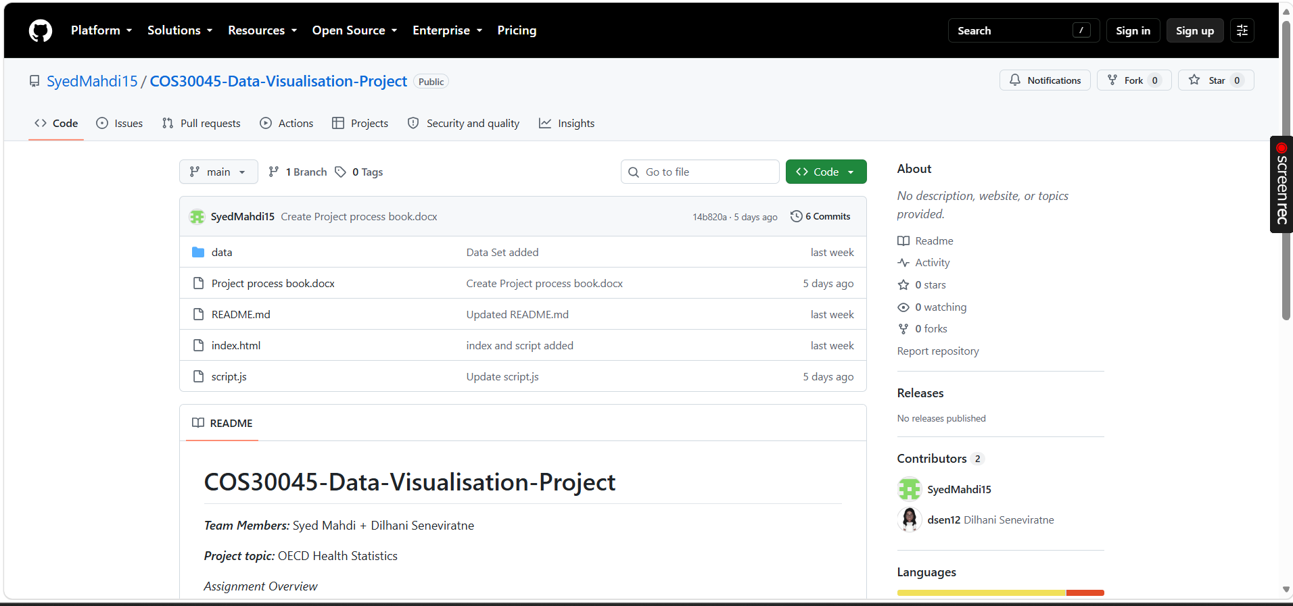
Dilhani
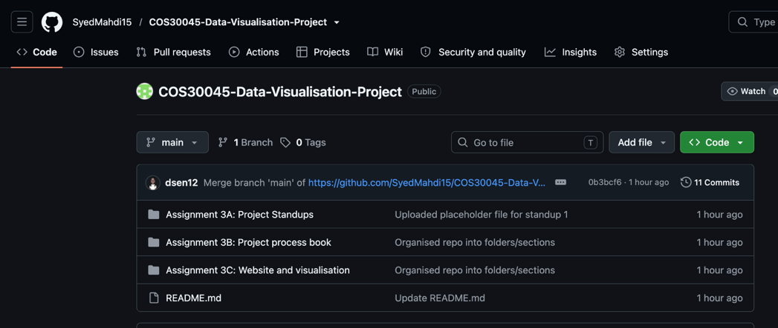

Communication channel
Syed
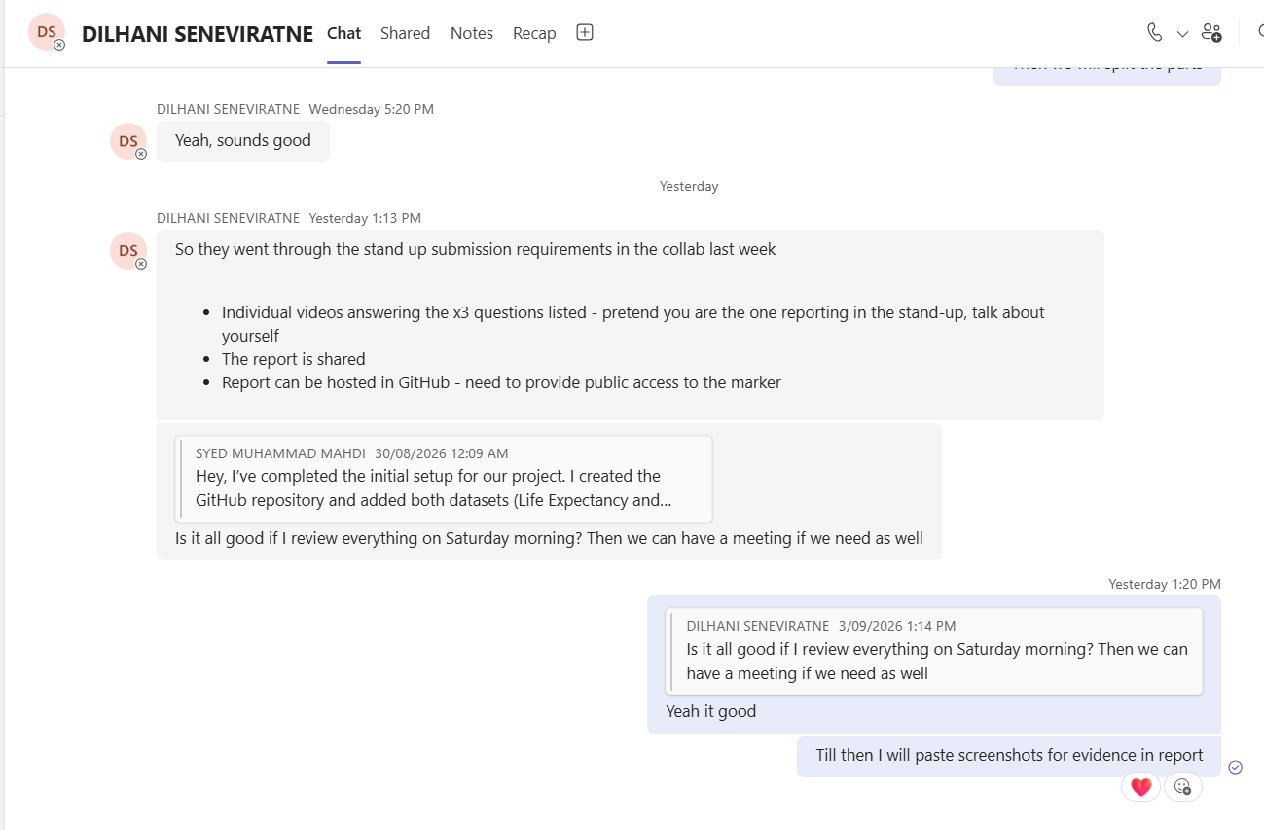
Dilhani
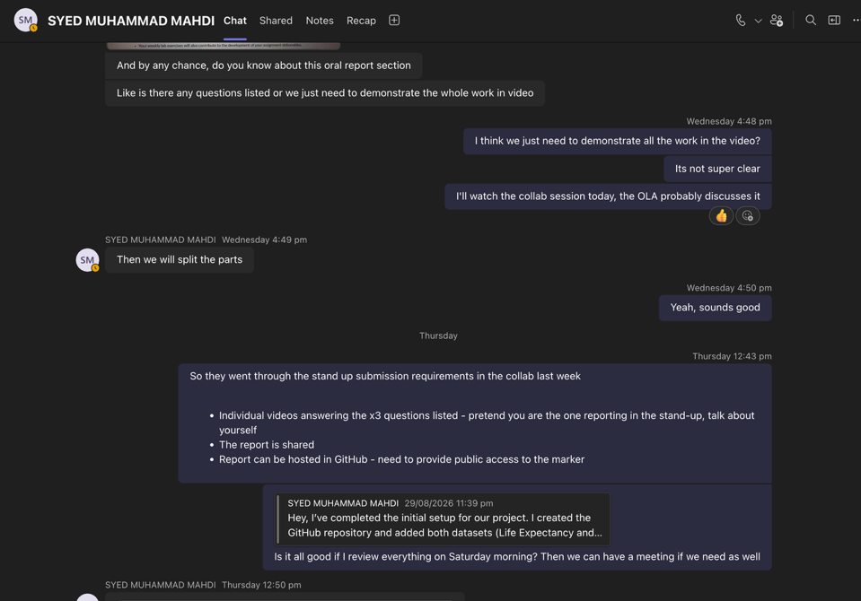

Project Schedule
To effectively monitor and manage progress throughout the Teaching Period, the project has been divided into six key phases:

Project Initiation & Planning

Project Setup & Data Collection

Data Preparation & Design

Development & Implementation

Testing, Evaluation & Reflection

Finalisation & Submission

Period | Planned Work | Assessment Due
Weeks 4 + 5 | Project Initiation & Planning  - Establish team communication and collaboration channels.  - Review project requirements.  - Discuss project topics.
Week 6 | - Select OECD Health Statistics topic + visualisation purpose questions.  - Identify datasets to be utilised for the visualisations.
Week 7 | Project Setup & Data Collection  - Create GitHub repository.  - Collect datasets.  - Begin initial website development (excluding visualisations).
Week 8 | Data Preparation & Design  - Complete standup 1 report.  - Document the project details for the project process book. | Assignment 3A: Project Standup 1
Week 9 | - Clean and process datasets.  - Finalise website design.  - Develop initial visualisation concepts.
Week 10 | Development & Implementation  - Develop D3 visualisations and interactive features.  - Complete standup 2 report. | Assignment 3A: Project Standup 2
Week 11 | - Refine data visualisations, website design and user interactions.  - Complete standup 3 report. | Assignment 3A: Project Standup 3
Week 12 | Testing, Evaluation & Reflection  - Test the website and visualisations.  - Implement improvements based on testing  - Complete standup 4 report.  - Commence project reflection and peer review. | Assignment 3A: Project Standup 4
Exam Period | Finalisation & Submission  - Finalise the Project Process Book for submission.  - Finalise the Website and Visualisation for submission.  - Complete project reflection and peer review. | Assignment 3B: Project process book  Assignment 3C: Website and visualisation  Assignment 3D: Project reflection and peer review

Teamwork Issues
Issue | Mitigation
The team has a conflict in schedules therefore a regular meeting time was unable to be scheduled, causing the team to communicate only via text. Although this was navigated throughout the preparation phase, it can be foreseen as an issue for the project further down the track. | Regular meetings will be held on midday, Saturdays or Sundays moving forward. These are scheduled before assessment deadlines.
Inconsistent communication from Dilhani due to work commitments. | Dilhani has committed to regular updates with regards to tasks guided by the weekly scheduled meetings as an internal deadline.

Overall risk mitigation strategy:
Risk | Mitigation
Uneven workload distribution among team members. | Tasks will be collaboratively assigned to each team member.
A team member misses deadlines. | Internal deadline are set before official due dates. Progress is monitored during standup meetings.
Team conflicts or disagreements on project decisions. | Open discussions are held with outcomes documented. OLA will be engaged if required.

